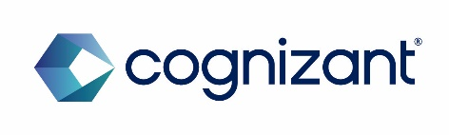

Matrix cluster

/COGNIZANT WORLDWIDE LIMITED

CONFIDENTIAL

  - Matrix (Neo) Integration Hub -Security High Level Design

Cognizant Technology Solutions
280 Bishop Gate
London EC2M 4RB
www.cognizant.com

Table of Contents

1 DOCUMENT HISTORY, VERSION, AND AUTHORS 4
1.1 Document Version and Authors 4
2 ACRONYMS 5
3 DOCUMENT PURPOSE AND EXECUTIVE SUMMARY 7
3.1 Executive Summary 7
3.2 Purpose 7
4 Context and Scope 8
4.1 Business Context 8
4.2 Technical Scope – Multi-account architecture 8
4.3 Development phase considerations 9
5 ARCHITECTURal Overview 11
5.1 Security Architecture principles 11
5.2 Multi-account Architecture 11
5.3 Data Flow security Model 13
5.4 integration with organization security infrastructure 14
6 Shared Responsibility Matrix 15
6.1 AWS Shared Responsibility Model 15
6.2 Account Specific Responsibility Allocation 15
6.3 Cross Account Responsibilities 15
7 Thrreat Model and Assumptions 17
7.1 Threat Landscape Assessment 17
7.2 Attack Vector Analysis 17
7.3 Security Assumptions 18
8 Identity and ACcess Controls 19
8.1 Multi-Account Identity Architecture 19
8.2 Role Based Access Control (RBAC) 19
8.3 Multi-Factor Authentication (MFA) 20
8.4 Privileged Access Management (PAM) 20
9 Network Security 21
9.1 Multi-Account Network Architecture 21
9.2 Perimeter Security Controls 21
9.3 Network Segmentation and Micro-segmentation 22
10 Crypto and Key management 23
10.1 Encryption Strategy 23
10.2 Key Management Architecture 23
10.3 Secret Management 23
11 Logging and Monitoring 25
11.1 Centralised Logging Architecture 25
11.2 Security Monitoring 27
11.3 Automated Threat Detection 28
12 Vulnerability and Threat Detection 29
12.1 Vulnerability Management 29
12.2 Threat Intelligence Integration 30
12.3 Incident Detection and Response 30
13 Data Classification and Handling 31
13.1 Government Security Classifications Implementation 31
13.2 Automated Data Classification 31
13.3 Classification-Based Access Controls 31
14 Business Continuity and Disaster Recovery 33
14.1 Single-Region Resilience Strategy 33
14.2 Account-Level Resilience 33
14.3 Recovery Procedure 33
15 Secure SDLC/DevSecOps PipeLine 35
15.1 Development Security Integration 35
15.2 Automated Security Gates 35
15.3 Infrastructure as Code Security 36
16 Third Party/Supply Chain risk 37
16.1 Vendor Risk Management Framework 37
16.2 Software Supply Chain Security 37
17 AWS Security Services Overview 38
18 DOCUMENTS REFERENCED 40

DOCUMENT HISTORY, VERSION, AND AUTHORS
Heading Text goes here

Document Version and Authors

Date | Version | Name | Role | Comments
15 July 2025 | 0.1 | Abdul Khader Abdul Hanif, Sam Mathew, Viswanathan Mareeswaran | Cloud Security Architects | Initial version
17 July 2025 | 0.2 | Abdul Khader Abdul Hanif, Sam Mathew | Cloud Security Architects | Updated document based on input received from Infrastructure and project team
21 July 2025 | 1.0 | Sam Mathew | Cloud Security Architects | Final version for customer review

ACRONYMS
Acronym | Definition
ACL | Access Control List
ACM | AWS Certificate Manager
API | Application Programming Interface
APT | Advanced Persistent Threat
AWS | Amazon Web Services
BoM | Bill of Material
CICD | Continuous Integration and Continuous Delivery
CMK | Customer Managed Key
CSPM | Cloud Security Posture Management
CVE | Common Vulnerability and Exposures
DDoS | Distributed Denial of Service
DIST | Department for Science, Innovation & Technology
DNS | Domain Name Service
EBS | Amazon Elastic Block Store
ECR | Amazon Elastic Container Registry
EKS | Amazon Elastic Kubernetes Service
GDPR | General Data Protection Regulation
HLD | High Level Design
HTTP | Hypertext Transfer Protocol
IAM | Identity and Access Management
KMS | Key Management Service
MFA | Multi-Factor Authentication
NCSC | National Cyber Security Centre
NIST | National Institute of Standards and Technology
OWASP | Open Web Application Security Project
PAM | Privileged Access Management
RBAC | Role Based Access Control
RDS | Relational Database Service
RPO | Recovery Point Objective
RTO | Recovery Time Objective
SAST | Static Application Security Testing
SBOM | Software Bill of Material
SCA | Software Composition Analysis
SDK | Software Development Kit
SIEM | Security Information and Event Management
SOC | Security Operations Centre
SSH | Secure Shell
SSO | Single Sign-On
TLS | Transport Layer Security
VPC | AWS Virtual Private Cloud
WAF | Web Application Firewall

DOCUMENT PURPOSE AND EXECUTIVE SUMMARY

Executive Summary
This document provides a comprehensive security-specific High-Level Design (HLD) for the Matrix (neo) Integration Hub, a cloud-based data exchange platform designed to facilitate secure data integration between Workday SaaS, financial systems, and downstream applications within the DSIT organisation. The platform leverages Amazon Web Services (AWS) infrastructure and implements a zero-trust security architecture aligned with the National Cyber Security Centre (NCSC) Cloud Security Principles and AWS Well-Architected Security Pillar.
The Matrix Integration Hub serves as a critical component in the organisation's data ecosystem, handling sensitive government data through secure SFTP and HTTPs interfaces. This design ensures compliance with integration hub security requirements agreed as part of the Schedule 02 and Schedule 05 whilst maintaining operational efficiency and scalability. The architecture implements defence-in-depth security controls, comprehensive monitoring, and automated threat detection capabilities to protect against evolving cyber threats. Key security features include end-to-end encryption, multi-factor authentication, network segmentation and continuous monitoring. The design incorporates lessons learned from industry best practices and aligns NCSC standards.

Purpose
This Security High-Level Design document serves multiple critical functions within the Matrix Integration Hub project lifecycle. Primarily, it captures the agreed security architecture based on the Bill of Materials (BoM), establishing a canonical reference for all security-related decisions and implementations. The document maps security controls to industry-recognised baselines including the NCSC Cloud Security Principles, CIS AWS Foundations Benchmark and NIST Cybersecurity Framework.
The design addresses the unique security challenges associated and it establishes clear security boundaries, defines roles and responsibilities, and provides a framework for continuous security improvement and adaptation to emerging threats.

Context and Scope

Business Context
The Matrix Integration Hub represents a strategic initiative to modernise the organisation's data integration capabilities, replacing legacy point-to-point integrations with a centralised, secure, and scalable platform. Currently in the development phase, the hub is designed to facilitate data exchange between critical business systems including Workday SaaS for human resources management, various financial systems for budget and procurement data, and downstream applications supporting operational decision-making.
The platform operates within a regulatory environment aligned to NCSC security guidance. The organisation handles data across multiple classification levels, from routine OFFICIAL information to SENSITIVE PII information, requiring robust security controls and clear segregation mechanisms even during the development phase.
The new platform provides a foundation for implementing consistent security policies, automated monitoring, and standardised data handling procedures across all integration points whilst supporting iterative development and testing activities.

Technical Scope – Multi-account architecture
The security design encompasses all components of the Matrix Integration Hub infrastructure across the workload and non-workload account architecture, including ingress and egress data flows, processing components, storage systems, and management interfaces. The scope includes security controls for data in transit, data at rest, and data in processing, covering the complete data lifecycle from initial ingestion through final delivery to downstream systems.
Workload and non-workload environment comprise of the AWS accounts below:

Workload accounts: Prod, Pre-Prod, NFT, End-To-End(E2E) and Development (DEV) AWS accounts

Non-Workload Accounts: Network, Security, Logging. Shared AWS accounts

- Neo-network Account: Handles all ingress and egress traffic patterns with CheckPoint Cloud Guard firewall providing perimeter security and advanced threat protection. This account serves as the primary security gateway for all external communications and implements comprehensive network security controls.
- Neo-sharedservices Account: Hosts development-focused security services including Amazon Elastic Container Registry (ECR) with vulnerability scanning using Amazon Inspector, and Amazon CodeGuru integrated with CI/CD pipelines for automated code security analysis. This account provides centralised security tooling for the development lifecycle.
- Neo-securityaudit Account: Serves as the central audit account hosting aggregators for all security services findings, including AWS Security Hub CSPM (Cloud Security Posture Management), Amazon GuardDuty for threat detection, AWS Config for configuration compliance, Amazon Inspector for vulnerability assessment, AWS Access Analyzer for access policy analysis, and Amazon Macie for data security monitoring. This account is designed for future integration with the Security Operations Centre (SOC), particularly for GuardDuty findings analysis.
- Neo-logging Account: Provides centralised logging capabilities hosting Amazon S3 buckets for all audit and access logs across the platform. This account is essential for triaging issues as part of incident management and maintaining comprehensive audit trails for compliance purposes.
- Workload Accounts: Hosts the core integration platform components including AWS Web Application Firewall (WAF) associated with API Gateway to intercept incoming traffic and evaluate against OWASP Top 10 rulesets, AWS Secrets Manager for secure credentials storage, and AWS Certificate Manager for public certificate management.
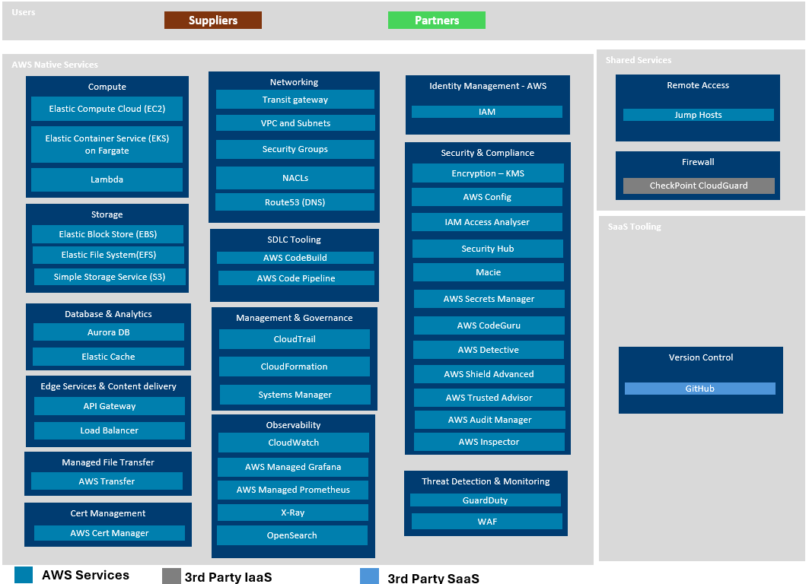

Development phase considerations
The current development phase requires specific security considerations that balance robust protection with development agility. Security controls are implemented to protect development data and infrastructure whilst enabling rapid iteration and testing of integration workflows. The multi-account structure provides natural isolation between different functions whilst maintaining centralised security monitoring and compliance oversight.

Development security practices include secure coding standards enforced through CodeGuru integration, automated vulnerability scanning of container images through Inspector, and comprehensive logging of all development activities for security analysis and compliance purposes. The architecture supports secure development practices whilst preparing for eventual production deployment with minimal security control modifications.

ARCHITECTURal Overview

Security Architecture principles
The Matrix Integration Hub security architecture is founded upon zero-trust principles, which assume that no network, device, or user should be trusted by default, regardless of their location or previous authentication status. This approach is particularly relevant for government organisations that must protect against sophisticated threat actors and insider threats whilst maintaining operational efficiency during development and eventual production operations.
The architecture implements defence-in-depth strategies with multiple layers of security controls distributed across the workload and non-workload account structure, ensuring that the compromise of any single component does not result in complete system failure. Each account provides independent security capabilities whilst contributing to the overall security posture through coordinated monitoring and response mechanisms centralised in the Neo-securityaudit account.
Security controls are designed to be transparent to legitimate users whilst providing robust protection against unauthorised access attempts. The architecture emphasises automation wherever possible to reduce the risk of human error and ensure consistent application of security policies across all platform components and accounts.

Multi-account Architecture
The security design encompasses all components of the Matrix Integration Hub infrastructure across the Workload and non-workload account architecture, including ingress and egress data flows, processing components, storage systems, and management interfaces. The scope includes security controls for data in transit, data at rest, and data in processing, covering the complete data lifecycle from initial ingestion through final delivery to downstream systems.
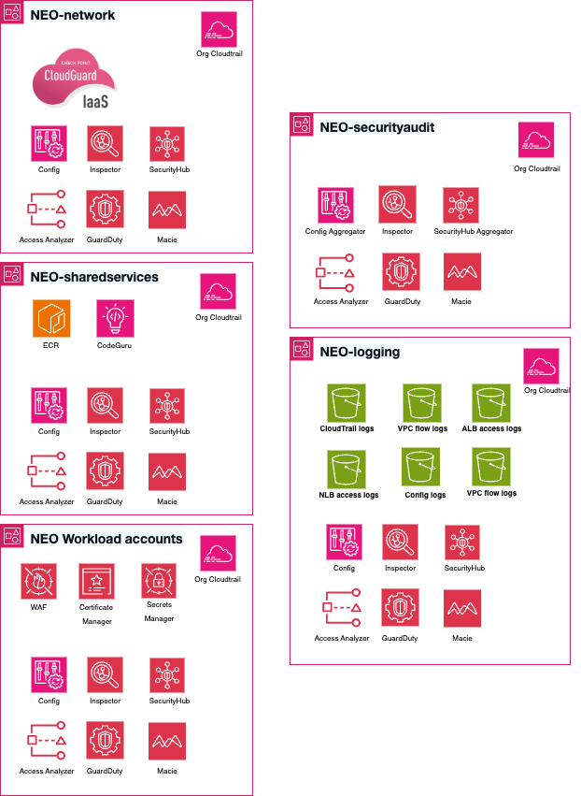

Account | Purpose
Neo-network | - Handles Ingress and Egress Traffic pattern with CheckPoint Cloud Guard firewall
Neo-sharedservices | - ECR vulnerability scanning using Inspector  - CodeGuru integrated with CI/CD for code scanning
Neo-securityaudit | - Central audit account hosting aggregators for all security services findings covering Security Hub CSPM, GuardDuty, Config, Inspector, Access Analyzer and Macie.  - Future integration with SOC especially for GuardDuty findings analysis.
Neo-logging | - Central logging account hosting S3 buckets for all the audit and access logs.  - Useful for triaging any issues as part of incident management
Workload accounts | - Hosts AWS WAF for association with API Gateway to intercept incoming traffic and evaluates against OWASP Top 10 rulesets  - Secrets Manager for credentials storage  - AWS Certificate Manager for Public cert Management

Data Flow security Model
Data flows through the integration hub follow a structured security model that ensures appropriate protection at each stage of processing across the multi-account architecture. Incoming data from Workday SaaS and other external sources is initially received through the Neo-network account's CheckPoint Cloud Guard firewall, which provides comprehensive threat detection and prevention capabilities.
Upon passing perimeter security controls, data flows to the workload account where API Gateway with integrated WAF performs application-layer security validation including OWASP Top 10 protection. Valid data is then processed through transformation engines that operate within isolated execution environments to prevent cross-contamination between different data sources.

The data from upstream sources, during the processing within Integration Hub will be stored in encrypted form within secure storage systems that implement role-based access controls and comprehensive audit logging. All data access activities are logged to the Neo-logging account for centralised audit trail management and compliance reporting. Data egress follows similar security procedures via Checkpoint CloudGuard Firewall, with additional validation to ensure that only authorised recipients receive appropriate data subsets based on their access permissions and business requirements.

integration with organization security infrastructure

The Matrix Integration Hub integrates seamlessly with the organisation's existing security infrastructure, leveraging established identity providers, security monitoring systems, and incident response procedures. This integration ensures consistent security policies across all organisational systems whilst avoiding duplication of security capabilities.
The platform has implemented AWS Single Sign-On (SSO) using IAM Identity Center, enabling single sign-on capabilities, MFA and centralised user lifecycle management across all accounts. Security events generated by the integration hub are aggregated in the Neo-securityaudit account and can be forwarded to the organization’s Security Information and Event Management (SIEM) system for correlation with events from other organisational systems.

Shared Responsibility Matrix

AWS Shared Responsibility Model

The AWS Shared Responsibility Model forms the foundation for understanding security responsibilities within the Matrix Integration Hub's multi-account architecture. AWS assumes responsibility for the security "of" the cloud, including the physical infrastructure, hardware, software, networking, and facilities that run AWS services across all accounts.

AWS maintains responsibility for the hypervisor and below, including the physical security of data centres, environmental controls, power systems, and network infrastructure. AWS also manages the security of managed services such as Amazon RDS, Amazon S3, AWS Lambda, and the specialised services used across the platform including Security Hub, GuardDuty, Inspector, and Detective.
The organisation assumes responsibility for security "in" the cloud across all accounts, including customer data, identity and access management, operating system updates and security patches for EC2 instances, network traffic protection through security groups and network ACLs, and application-level security controls implemented within each account.

Account Specific Responsibility Allocation

Security Domain | AWS Responsibility | Neo-network | Neo-sharedservices | Neo-securityaudit | Neo-logging | Workload Accounts
Physical Security | Data centre security, environmental controls | - | - | - | - | -
Network Infrastructure | VPC infrastructure, AWS backbone | Firewall config | - | - | - | Network policies
Identity Management | IAM service availability | - | Service accounts | Audit roles | Log access roles | App user management
Data Protection | Encryption services (KMS) | Traffic encryption | Image encryption | Finding encryption | Log encryption | Data encryption
Monitoring & Logging | Service infrastructure | Traffic logs | Build logs | Security findings | Centralised logs | Application logs
Vulnerability Management | Service patching | Firewall updates | Scanner updates | Tool updates | Storage updates | App patching

Cross Account Responsibilities

The multi-account architecture introduces additional complexity in responsibility allocation, particularly for cross-account access and security monitoring. Cross-account IAM roles enable secure communication between accounts whilst maintaining appropriate access controls and audit trails.

The Neo-securityaudit account assumes responsibility for aggregating and analysing security findings from all other accounts, requiring appropriate cross-account permissions to collect security data whilst maintaining the principle of least privilege. This centralised monitoring approach ensures comprehensive security visibility whilst maintaining account isolation.

The Neo-logging account serves as the central repository for audit data from all accounts, requiring secure cross-account log delivery mechanisms and appropriate retention policies. This account must maintain the integrity and availability of audit data whilst providing appropriate access for incident investigation and compliance reporting.

The Neo-sharedservices account hosts the central ECR registry that contains all the container images and inspector scanning is performed against this registry to identity, report and remediate vulnerabilities

The Neo-network account forms the central hub with rest of the accounts serving as spokes. It hosts the Checkpoint CloudGuard firewall that enables the central ingress and egress capability for the platform and effectively providing the IPS capability.

Thrreat Model and Assumptions

Threat Landscape Assessment

The Neo Integration Hub operates within a threat environment characterised by sophisticated nation-state actors, organised cybercriminal groups, and potential insider threats targeting UK government systems. The platform's role as a central data integration point makes it an attractive target for adversaries seeking to gain access to sensitive government information or disrupt critical business operations.

Advanced Persistent Threat (APT) groups represent the most significant external threat, possessing sophisticated capabilities including zero-day exploits, advanced social engineering techniques, and the resources to conduct long-term campaigns against government targets. These actors may attempt to compromise the platform through various attack vectors including supply chain attacks against third-party components, spear-phishing campaigns targeting authorised users, and exploitation of vulnerabilities in internet-facing services.

Cybercriminal organisations pose additional threats through ransomware attacks, data theft for financial gain, and business email compromise schemes targeting the organisation's personnel. These threats are particularly relevant during the development phase when security controls may be less mature and development data may be perceived as easier targets.

Insider threats encompass both malicious insiders with legitimate access who may abuse their privileges for personal gain or ideological reasons, and unintentional insider threats resulting from human error, social engineering, or inadequate security awareness. The multi-account architecture provides natural boundaries to limit the potential impact of insider threats.

Attack Vector Analysis
External Network Attacks: Adversaries may attempt to exploit internet-facing services including the CheckPoint Cloud Guard firewall in the Neo-network account, API Gateway endpoints in the Workload account, AWS Transfer for SFTP and any publicly accessible management interfaces. The platform implements comprehensive network security controls including intrusion detection, DDoS protection using WAF and Shield, and application-layer filtering to mitigate these threats.

Supply Chain Compromise: Third-party components including container images stored in ECR, software libraries used in development, and external service such as GitHub SaaS, represent potential attack vectors. The platform addresses these risks through vulnerability scanning with Inspector, software composition analysis through CodeGuru.

Credential Compromise: Adversaries may attempt to compromise user credentials, API credentials through phishing attacks, credential stuffing, or exploitation of weak authentication mechanisms. The platform implements multi-factor authentication and comprehensive credential monitoring to detect and prevent credential-based attacks.

Data Exfiltration: Attackers may attempt to exfiltrate sensitive data through various means including unauthorised API access, database compromise, or abuse of legitimate data export functions. The platform implements data loss prevention controls, comprehensive audit logging in the Neo-logging account, and network monitoring to detect and prevent data exfiltration attempts.

Security Assumptions

The security architecture is based on several key assumptions about the operational environment and threat landscape. These assumptions are regularly reviewed and updated as the threat environment evolves and the platform transitions from development to production operations.

Trusted Network Assumption: The platform assumes that the AWS infrastructure provides a trusted foundation with appropriate physical security, environmental controls, and infrastructure protection. This assumption is validated through AWS compliance certifications and regular security assessments.

Identity Provider Trust: The architecture assumes that the organisation's identity management systems provide reliable authentication and authorisation services. This assumption requires ongoing validation through identity system security assessments and monitoring of authentication events.

Vendor Security: The platform assumes that key vendors including AWS, CheckPoint, and Workday maintain appropriate security controls and will promptly notify customers of security incidents that may affect their services. This assumption is validated through vendor security assessments and contractual security requirements.

Personnel Security: The architecture assumes that personnel with access to the platform have undergone appropriate background checks and security training. This assumption requires ongoing validation through personnel security reviews and security awareness training programmes.

Identity and ACcess Controls

Multi-Account Identity Architecture

The Matrix Integration Hub implements a sophisticated identity and access management architecture that spans all AWS accounts whilst maintaining appropriate security boundaries and enabling centralised management. AWS Single Sign-On (SSO) using IAM Identity Center provide seamless authentication across all platform components.

Each account maintains its own set of IAM roles and policies tailored to the specific security requirements and operational needs of that account. Cross-account access is implemented through carefully designed trust relationships that enable necessary inter-account communication whilst maintaining the principle of least privilege and comprehensive audit trails.

The Neo-securityaudit account maintains specialised roles for security monitoring and incident response that provide read-only access to security-relevant resources across all accounts. These roles enable comprehensive security oversight whilst preventing unauthorised modifications to production systems or sensitive data.

Role Based Access Control (RBAC)

The platform implements a comprehensive RBAC model that aligns with organisational roles and responsibilities whilst providing appropriate access controls for the development environment. Access permissions are granted based on job functions, project assignments, and security clearance levels, with regular reviews to ensure continued appropriateness.

Development Team Roles: Developers working on integration platform components receive access to development resources within the Neo-interhub dev and Neo-sharedservices accounts, including the ability to deploy code, access development databases, and view application logs. These roles include restrictions on production data access and sensitive configuration changes.

Security Team Roles: Security personnel receive comprehensive monitoring and analysis capabilities across all accounts through roles in the Neo-securityaudit account. These roles provide access to security findings, audit logs, and incident response tools whilst maintaining appropriate separation from development activities.

Infra Team Roles: Operations personnel receive administrative access to monitoring, logging, and infrastructure management capabilities across relevant accounts. These roles enable system administration and troubleshooting activities whilst maintaining appropriate controls on sensitive operations.

DevOps Team Roles: DevOps team are responsible for configuring the build and deployment pipelines as part of the SDLC for the applications. They will require configuration access for the AWS Native CI/CD tools such as AWS CodeBuild, CodePipeline and ability to create relevant service roles for the CI/CD integration.

Multi-Factor Authentication (MFA)

Multi-factor authentication is mandatory for all human access to the Neo Integration Hub across all accounts, implementing NCSC guidance on multi-factor authentication for online services. The platform supports MFA methods including mobile authenticator applications, and SMS-based authentication to accommodate different user preferences and security requirements.

Administrative access to any account requires MFA in line with security best practices. This requirement applies to all privileged operations including infrastructure changes, security configuration modifications, and access to sensitive data.

Service accounts and automated processes utilise IAM roles with temporary credentials rather than long-term access keys, eliminating the need for MFA whilst providing appropriate security controls through role-based permissions and comprehensive audit logging.

Privileged Access Management (PAM)
Currently there is no PAM capability / tooling considered as part of the BOM (Bill of Materials) for the current phase. This would need to be reviewed and revisited based on further discussions with DSIT security personnel and the programme team

Network Security

Multi-Account Network Architecture

The Matrix Integration Hub network architecture implements a sophisticated security model that leverages the natural isolation provided by the multi-account structure whilst enabling necessary communication between accounts and external systems. Each account maintains its own Virtual Private Cloud (VPC) with carefully configured security groups, network access control lists (NACLs), and routing policies.

The Neo-network account serves as the primary network security gateway, hosting the CheckPoint Cloud Guard firewall that provides advanced threat protection for all ingress and egress traffic. This centralised approach ensures consistent application of network security policies whilst enabling comprehensive monitoring and logging of all network communications.

Inter-account communication utilises the Transit gateway (TGW) hub and spoke architecture and all the spoke VPCs are attached the TGW for central routing orchestration providing a single pane of control for network routing management across the different VPCs. AWS VPC endpoints are to maintain secure, private connectivity without exposing traffic to the public internet. These connections are configured with minimal necessary permissions and comprehensive logging to support security monitoring and incident investigation.

Perimeter Security Controls
The CheckPoint Cloud Guard firewall in the Neo-network account implements comprehensive perimeter security controls including next-generation firewall capabilities, intrusion prevention systems, and advanced threat protection. The firewall is configured to inspect all traffic flows and apply security policies based on application identification, user identity, and content analysis.

Distributed Denial of Service (DDoS) protection is provided through AWS Shield Advanced, which offers enhanced DDoS mitigation capabilities and 24/7 access to the AWS DDoS Response Team. This protection is particularly important for internet-facing services including API Gateway endpoints and management interfaces.

Web Application Firewall (WAF) protection is implemented at the application layer through AWS WAF integrated with API Gateway in the Workload accounts. The WAF is configured with OWASP Top 10 rulesets and custom rules tailored to the specific threats facing government integration platforms.

Network Segmentation and Micro-segmentation
The platform implements comprehensive network segmentation using a combination of account-level isolation, VPC-level separation, and subnet-level micro-segmentation. This layered approach ensures that compromise of any single network segment does not result in lateral movement across the entire platform.

Each account maintains separate network segments for different functions, with the workload accounts implementing additional micro-segmentation between development, testing, and staging environments. This segmentation supports secure development practices whilst maintaining appropriate isolation between different phases of the development lifecycle.

Application-level micro-segmentation is implemented through security groups that control traffic flows between individual application components. These security groups are configured with minimal necessary permissions and are regularly reviewed to ensure continued appropriateness as the platform evolves.

The application microservices are hosted on AWS EKS Fargate cluster and the compute is managed by AWS including patching and hardening on the Fargate compute itself. Security groups block communication between the Fargate Data Plane EC2 instances to segregate instance-to-instance traffic within the Fargate VPC. VPC flow logs, CloudTrail, and DNS logs are enabled and monitored to detect and respond to security events within the Fargate VPC. The pod-to-pod communication is managed using pod security standards and the privileges are managed using IRSA at the individual pod level on the EKS cluster.

Crypto and Key management

Encryption Strategy
The Matrix Integration Hub implements comprehensive encryption controls for data protection across all accounts, utilising AWS Key Management Service (KMS) as the central cryptographic service provider. All data is encrypted both in transit and at rest using industry-standard algorithms that comply with NCSC cryptography guidance and government-approved cryptographic standards.

Data in transit encryption utilises TLS 1.2 and above for all communications between platform components, external systems, and user interfaces. The CheckPoint Cloud Guard firewall in the Neo-network account enforces TLS requirements and prevents downgrade attacks that could compromise communication security. Certificate management is centralised through AWS Certificate Manager in each workload account, ensuring consistent certificate lifecycle management and automatic renewal.

Data at rest encryption is implemented using AES-256 encryption with customer-managed keys stored in AWS KMS. Each account maintains its own set of encryption keys appropriate to the sensitivity of data processed within that account, with the Neo-logging account utilising enhanced key protection for audit data and the Neo-securityaudit account implementing additional controls for security findings and incident data.

Key Management Architecture

The platform implements a hierarchical key management architecture that provides appropriate key protection whilst enabling efficient cryptographic operations across the multi-account structure. AWS Managed Keys or Customer Master Keys (CMKs) are used within each account based on the specific security requirements and data sensitivity levels.

Cross-account key sharing is implemented through carefully controlled key policies that enable necessary cryptographic operations whilst maintaining appropriate access controls and audit trails. The Neo-securityaudit account maintains read-only access to key usage logs from all accounts to support security monitoring and compliance reporting.

Key rotation is implemented automatically for all AWS managed keys following standard AWS rotation schedules. For customer-managed keys, the rotation schedules are based on data sensitivity and regulatory requirements.

Secret Management

AWS Secrets Manager in the workload accounts provides secrets management for application credentials, API keys, and other sensitive configuration data. Secrets are encrypted using AWS managed keys and are accessed through IAM roles that implement least-privilege access principles.

Database credentials, API keys for external services, and other application secrets are stored in Secrets Manager with automatic rotation capabilities where supported by the target systems. This approach eliminates hardcoded credentials in application code and provides comprehensive audit trails for all secret access activities.

Integration credentials for external systems including Workday SaaS are managed through Secrets Manager with additional approval workflows for credential modifications. These credentials are subject to regular review and rotation to maintain security whilst ensuring continued service availability.

Logging and Monitoring

Centralised Logging Architecture

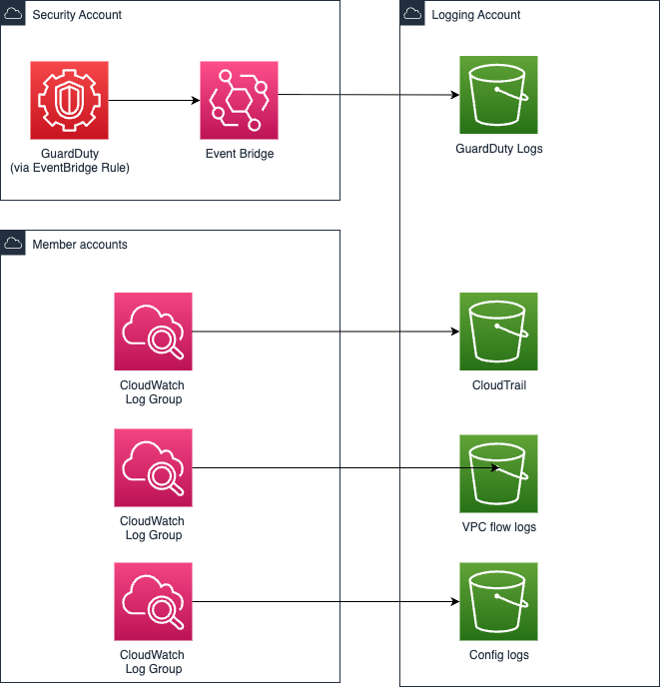

The Neo-logging account serves as the central repository for all audit and operational logs generated across the integration hub platform. This centralised approach ensures comprehensive audit coverage whilst providing efficient log management and analysis capabilities for security monitoring and compliance reporting.

AWS CloudTrail is configured across all accounts to provide comprehensive API activity logging, with all CloudTrail logs delivered to encrypted S3 buckets in the Neo-logging account. CloudTrail configuration includes data events for sensitive resources and insight events for unusual activity patterns that may indicate security incidents.

VPC Flow Logs are enabled across all accounts to provide detailed network traffic analysis capabilities, supporting both security monitoring and performance optimisation activities. Flow logs are processed through automated analysis tools that identify suspicious traffic patterns and potential security incidents.

Application logs from integration platform components are collected through AWS CloudWatch Logs and forwarded to the centralised logging infrastructure in the Neo-logging account. Log aggregation includes structured logging formats that support automated analysis and correlation with security events from other platform components.

Log / Finding | Source | Collection | Storage (Logging account)
API activity | Org CloudTrail | EventBridge pipe | S3 (bucket SSE‑AWS‑KMS)
VPC Flow Logs | VPC | CloudWatch Logs | Logs bucket
WAF logs | AWS WAF | CloudWatch Logs | Logs bucket
GuardDuty & Inspector findings | Detector / Scan | Security Hub | SHub aggregator
EKS audit | EKS control‑plane | CloudWatch Logs | Logs bucket

Security Monitoring

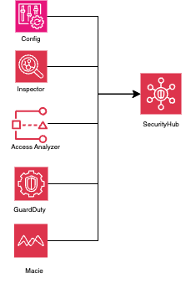

The Neo-securityaudit account hosts comprehensive Security monitoring capabilities through AWS Security Hub, which aggregates security findings from multiple AWS security services including GuardDuty, Inspector, Config, Access Analyzer, and Macie. This centralised approach provides unified security monitoring across all accounts whilst enabling correlation of security events and automated response capabilities.

AWS GuardDuty provides intelligent threat detection using machine learning algorithms to identify malicious activity including cryptocurrency mining, reconnaissance attacks, and data exfiltration attempts. GuardDuty findings are automatically forwarded to Security Hub for correlation with other security events and integration with incident response workflows.

Amazon Detective enhances incident investigation capabilities by automatically collecting log data from AWS resources and using machine learning to build a linked set of data that enables security teams to conduct faster and more effective investigations. Detective integration provides detailed forensic capabilities for security incidents affecting any component of the platform.

AWS Config provides continuous compliance monitoring by evaluating AWS resources against security configuration standards and organisational policies. Config rules are customised to reflect government security requirements and automatically generate findings for non-compliant resources.

Automated Threat Detection

The platform implements comprehensive automated threat detection capabilities through integration of multiple AWS security services with custom detection rules tailored to the specific threats facing government integration platforms. Machine learning algorithms analyse user behaviour, network traffic, and system activities to identify anomalous patterns that may indicate security incidents.

Amazon Macie provides automated discovery and protection of sensitive data including personally identifiable information (PII) and government classification markings. Macie continuously monitors data repositories and generates alerts when sensitive data is accessed inappropriately or stored in non-compliant locations.

AWS Access Analyzer continuously evaluates resource policies and access permissions to identify potential security risks including overly permissive policies, unused access permissions, and external access grants that may violate security policies. Access Analyzer findings are integrated with Security Hub for centralised security monitoring.

Custom CloudWatch metrics and alarms provide additional threat detection capabilities tailored to the specific operational patterns of the integration platform. These custom detections include unusual data transfer volumes, unexpected API usage patterns, and anomalous authentication activities that may indicate compromise.

Vulnerability and Threat Detection

Vulnerability Management

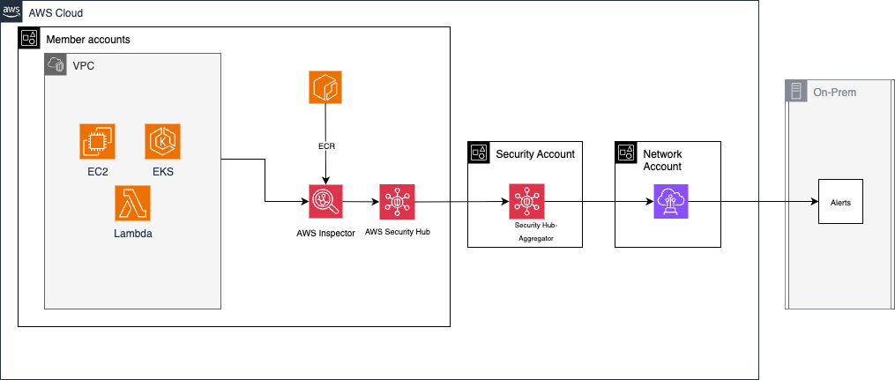

The Matrix Integration Hub implements a comprehensive vulnerability management programme that addresses vulnerabilities across all platform components and accounts. Amazon Inspector provides automated vulnerability assessment for EC2 instances and container images stored in ECR within the Neo-sharedservices account, identifying security vulnerabilities and providing prioritised remediation guidance.

Container image scanning is integrated into the CI/CD pipeline through CodeGuru and Inspector integration, ensuring that all container images are scanned for vulnerabilities before deployment. Vulnerability findings are automatically integrated with Security Hub in the Neo-securityaudit account for centralised tracking and remediation management.

AWS Trusted Advisor provides automated security recommendations across all accounts, identifying potential security improvements including unused security groups, overly permissive access policies, and missing security configurations. Trusted Advisor findings are reviewed regularly and integrated into the platform's continuous improvement processes.

AWS native code scanning tools such as CodeGuru can complement AWS inspector capabilities by providing additional coverage for application-layer vulnerabilities and custom code components. These tools are integrated with the centralised logging and monitoring infrastructure to provide comprehensive vulnerability visibility.

Threat Intelligence Integration

The platform integrates threat intelligence feeds natively from AWS GuardDuty which provides threat proactive threat detection and response based on current threat landscape information.

GuardDuty threat intelligence includes AWS-managed threat feeds, third-party commercial feeds, and custom threat intelligence sources relevant to government organisations. Threat intelligence is automatically applied to network traffic analysis, DNS query monitoring, and malware detection capabilities.

Indicators of Compromise (IoCs) are automatically distributed across all security monitoring systems through integration with Security Hub and custom automation workflows. This ensures that threat intelligence is rapidly applied to all platform components and accounts for comprehensive threat detection coverage.

Threat hunting capabilities are enhanced through integration with Amazon Detective, which provides detailed forensic analysis capabilities for investigating potential threats and understanding attack patterns. Detective's machine learning algorithms help identify subtle indicators of compromise that may not trigger traditional security alerts.

Incident Detection and Response
Automated incident detection capabilities are implemented through comprehensive monitoring and alerting systems that span all accounts. Security incidents are automatically detected through correlation of security events, anomaly detection algorithms, and rule-based detection systems tailored to government security requirements.

The Neo-securityaudit account serves as the central coordination point for incident response activities, providing access to security findings, audit logs, and forensic tools necessary for incident investigation. Integration with the Neo-logging account ensures that comprehensive audit trails are available for incident analysis and lessons learned activities.

Data Classification and Handling

Government Security Classifications Implementation
The Matrix Integration Hub has the capability to implement security controls based on the data classification and handling procedures aligned with the DSIT data classification standards. The multi-account architecture provides natural boundaries for implementing classification-based access controls and handling procedures.

Automated Data Classification

The platform will implement automated data classification capabilities through integration with Amazon Macie and custom classification algorithms that analyse data content, metadata, and source system information to determine appropriate classification levels. Machine learning algorithms trained on government classification guidelines assist in identifying sensitive information and applying appropriate classification labels.

Data classification labels are embedded in data metadata and are used to enforce appropriate security controls throughout the data lifecycle across all accounts. Classification information is maintained from initial ingestion in the Neo-interhub dev account through processing, storage, and eventual delivery to downstream systems.

Classification inheritance rules ensure that derived data products maintain appropriate classification levels based on the sensitivity of source data. When data from multiple classification levels is combined, the resulting data product receives the highest applicable classification level unless specific declassification procedures are followed.

Manual classification override capabilities enable authorised personnel to adjust classification levels when automated systems are unable to accurately determine appropriate classifications. These overrides are subject to approval workflows and comprehensive audit logging in the Neo-logging account to ensure accountability.

Classification-Based Access Controls
Access control systems across all accounts enforce classification-based restrictions to ensure that personnel can only access data appropriate to their security clearance level and business need-to-know. These controls are implemented through a combination of IAM policies, resource-based policies, and application-level access controls.

Clearance-based access controls verify that users possess appropriate security clearances before granting access to classified data. Integration with the organisation's personnel security system ensures that access permissions are automatically updated when clearance status changes, with immediate revocation of access when clearances are suspended or revoked.

Need-to-know determinations are made by data owners and are enforced through role-based access controls that limit access to specific data sets based on job responsibilities and project assignments. These determinations are regularly reviewed and updated as business requirements change, with comprehensive audit trails maintained in the Neo-logging account.

Compartmentalised access controls provide additional restrictions for highly sensitive data that requires special handling even within the same classification level. These controls ensure that access is limited to personnel with specific authorisations and business justifications, with enhanced monitoring and alerting for all access activities.

Business Continuity and Disaster Recovery

Single-Region Resilience Strategy

The Matrix Integration Hub implements comprehensive resilience strategies within a single AWS region (eu-west-2), utilising multiple Availability Zones and robust backup procedures to ensure continued service availability during various disruption scenarios. The multi-account architecture provides natural isolation that enhances resilience by preventing cascading failures between different platform functions.

High availability is achieved through deployment of critical components across multiple Availability Zones within the London (eu-west-2) region, with automatic failover capabilities for database systems, load balancers, and application components. The CheckPoint Cloud Guard firewall in the Neo-network account is configured in high-availability mode to ensure continued perimeter security during infrastructure failures.

Data backup strategies utilise AWS native backup services including automated RDS snapshots, S3 object lock enabled for critical audit logs in the Neo-logging account, and EBS snapshots for persistent storage volumes. Backup retention policies are aligned with business requirements and regulatory obligations, with regular restore testing to validate backup integrity.

Account-Level Resilience
Each account within the multi-account architecture implements specific resilience measures appropriate to its function and criticality. The Neo-securityaudit account maintains redundant security monitoring capabilities to ensure continued security oversight during infrastructure disruptions, with automated failover between monitoring systems and backup data sources.

The Neo-logging account implements enhanced data protection through multiple backup copies and cross-region replication for the most critical audit data. This ensures that audit trails remain available for incident investigation and compliance reporting even during significant infrastructure failures.

The non-workload accounts implement application-level resilience through containerised deployments with automatic scaling and recovery capabilities. Container orchestration through Amazon EKS provides automatic restart of failed containers and redistribution of workloads across available infrastructure.

Recovery Procedure
Disaster recovery procedures will be documented and regularly tested to ensure rapid restoration of integration platform services following major disruptions. Recovery procedures are prioritised based on business criticality and dependencies, with the most critical integration flows restored first to minimise business impact.

Recovery time objectives (RTO) and recovery point objectives (RPO) are defined for each critical platform component based on business requirements and technical constraints. These objectives guide the design of backup, replication, and recovery procedures to ensure that business requirements are met during disruption scenarios.

Communication procedures ensure that stakeholders are informed of recovery progress and expected service restoration timelines. These procedures include internal communications to technical teams and management, as well as external communications to partner organisations and service users.

Secure SDLC/DevSecOps PipeLine

Development Security Integration

The Matrix Integration Hub implements comprehensive security integration throughout the software development lifecycle, leveraging the security tools hosted in the Neo-sharedservices account to provide automated security testing and validation. Amazon CodeGuru integration with CI/CD pipelines provides automated code security analysis to identify potential vulnerabilities early in the development process.

Container image security is ensured through Amazon ECR integration with Inspector vulnerability scanning, which automatically scans all container images for known vulnerabilities before deployment. Vulnerability findings are integrated with Security Hub in the Neo-securityaudit account for centralised tracking and remediation management.

Static Application Security Testing (SAST) and Dynamic Application Security Testing (DAST) are integrated into the development pipeline to provide comprehensive vulnerability detection capabilities. These tools are configured with government-specific security rules and compliance requirements to ensure that developed code meets organisational security standards.

Automated Security Gates
The development pipeline implements automated security gates that prevent deployment of code that does not meet established security standards. These gates include vulnerability thresholds, code coverage requirements, and compliance with coding standards that are enforced automatically during the CI/CD process.

Security Hub score requirements ensure that deployed applications maintain a minimum-security posture as measured by AWS Security Hub findings across all accounts. Applications with Security Hub scores below defined thresholds are blocked from deployment until security issues are resolved.

Code review requirements ensure that all code changes are reviewed by qualified personnel before deployment, with security-focused review criteria and approval requirements from security team members for changes affecting security-critical components.

Infrastructure as Code Security
Infrastructure as Code (IaC) templates are subject to security scanning and validation to ensure that infrastructure deployments follow security best practices and comply with organisational policies. AWS CloudFormation templates configurations are analysed for security misconfigurations before deployment.

Third Party/Supply Chain risk

Vendor Risk Management Framework

The Matrix Integration Hub implements comprehensive vendor risk management procedures that address security risks associated with key suppliers including AWS, CheckPoint, Workday, and other technology vendors. Vendor security assessments evaluate security capabilities and practices before contract award and periodically throughout the contract lifecycle.

AWS security assessment includes review of compliance certifications, security incident disclosures, and alignment with government security requirements. The AWS shared responsibility model is clearly understood and documented, with regular review of AWS security practices and incident notifications.

CheckPoint Cloud Guard security assessment includes evaluation of firewall capabilities, threat intelligence feeds, and incident response procedures. Vendor support arrangements include provisions for emergency support during security incidents and regular security briefings on emerging threats.

Software Supply Chain Security
Software supply chain security addresses risks associated with third-party software components, libraries, and development tools used across all accounts. Software Bill of Materials (SBOM) documentation provides comprehensive inventory of all software components used in the platform, including version information and known vulnerabilities.

Vulnerability monitoring for software components provides automated alerts when new security vulnerabilities are discovered in components used by the platform. This monitoring includes both direct dependencies and transitive dependencies that may introduce security risks across the development and deployment pipeline.

Software integrity verification ensures that software components have not been tampered with during distribution or installation. This includes cryptographic signature verification, hash validation, and use of trusted software repositories and distribution channels. This is performed using AWS Inspector for container image scanning and AWS CodeGuru for SAST/SCA capabilities.

AWS Security Services Overview
The table below summarises every AWS‑native security service leveraged by the solution, why it is enabled, and how it integrates with the wider control plane.
# | Service | Purpose & key configuration | Integration / Output
1 | AWS Config | Records configuration items for all resources (global IAM included) in eu-west-2; org rules & conformance packs (NCSC CSP, CIS v3, CAF) deployed. | Findings flow to Security Hub; data streamed to Security Lake bucket in Logging account.
2 | AWS CloudTrail (Org trail) | Captures control-plane API calls in all regions; log-file validation & encryption on. | CloudTrail Lake queries; raw logs to Logging account S3.
3 | GuardDuty | Detects IAM, network, malware and EKS-runtime threats; S3 Protection enabled. | Findings → Security Hub aggregator; some events generate PagerDuty alerts.
4 | Amazon Inspector v2 | Continuous CVE scans on EC2, Lambda, and ECR images. | High/Critical findings surface in Security Hub and block CodePipeline promotions.
5 | Amazon Macie | Classifies Workday HR files placed in S3 (OFFICIAL-SENSITIVE). | Sensitive-data findings → Security Hub; option to quarantine.
6 | IAM Access Analyzer | Detect public / cross-account IAM policies & S3 ACLs. | Findings → Security Hub; delegated admin = Security-Audit account.
7 | AWS Security Hub (Aggregator) | Central findings plane; standards enabled: FSBP, CIS v3, NIST CSF, PCI DSS. | Aggregator region eu-west-2; member accounts auto-enrolled.
8 | Amazon Detective | Root-cause graph analysis across GuardDuty, CloudTrail, VPC Flow Logs. | Delegated admin: Security-Audit account.
9 | AWS WAF v2 | Blocks OWASP Top-10, Geo IP, and size attacks on API Gateway. | Logs → Kinesis Firehose → S3 (Logging).
10 | AWS Shield Standard | DDoS detection for public APIs; auto enabled. | Metrics in CloudWatch.
11 | AWS Secrets Manager | Stores SFTP SSH keys and Workday API secrets; auto-rotation disabled (SSH keys rotated quarterly manually). | Access via IRSA in EKS. SDK calls from other AWS services such as Lambda if needed
12 | AWS Key Management Service (KMS) | Centralised encryption-key control (CMKs), envelope encryption, automatic annual rotation, key policy/grant model, multi-region keys. | Integrated with 90+ AWS services (S3, EBS, RDS, Lambda, etc.); CloudTrail logs every Encrypt/Decrypt; CloudWatch metric KMS Requests; AWS Config rule kms-key-rotation-enabled.
13 | AWS Certificate Manager (ACM ) | Issue, import, and auto-renew TLS certs | Plugs into ALB/NLB, API-Gateway, VPC-Lattice; EventBridge renewal events; ListCertificates API inventory; cert-manager addon for EKS.
14 | AWS Audit Manager | Automated evidence collection for CIS, ISO, GDPR, NIST; create Assessments, choose accounts, map controls, set retention. | Pulls data from Config, CloudTrail, Security-Hub, IAM reports; exports evidence packs CSV/JSON & PDF; EventBridge status notifications.
15 | AWS Trusted Advisor | Continuous best-practice checks (Cost, Performance, Security, Fault-Tolerance, Limits); requires Business/Enterprise Support; weekly email digest. | Results in Support Center & Trusted Advisor API; optional import to Security- Hub; CSV exports;

DOCUMENTS REFERENCED

# | Document Name | Brief Description
1 | Matrix_Infra_Devops_IntegrationHub_HLD_8July2025 | Matrix Infrastructure and DevOps HLD
2 | Schedule 02 - Matrix Programme SI - Services  Description + 16 Appendices FINAL 040924(156860464.1) | Requirement document
3 | Schedule 05 - Matrix Programme SI – Security  Management FINAL 040924(156829661.1) | Requirement document

